1. Extended JSON is used to convert JSON into BSON and vice versa.
2. There are two modes of operation of the Extended JSON and those modes are called
   1. Shell Mode.
   2. Strict Mode.
3. 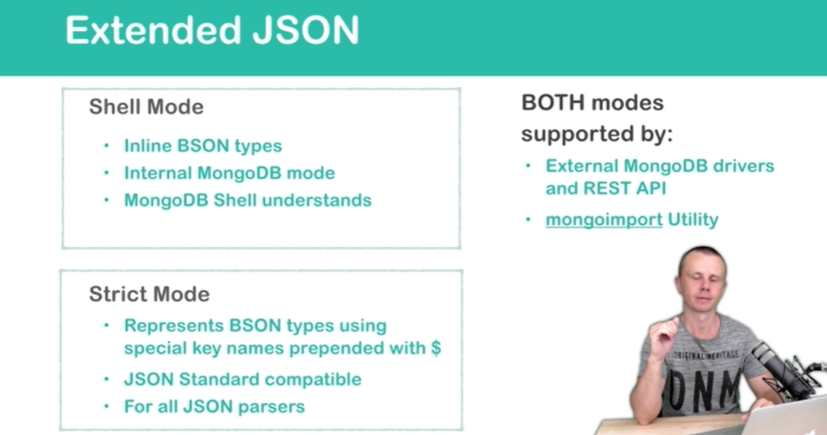
4. **Shell Mode**:
   1. This mode inline BSON types. It means along value, we also pass its type.
   2. This is internal MongoDB mode means outside of MongoDB, no one utility understands this.
   3. MongoDB shell understands this mode.
5. **Strict Mode**:
   1. Represents BSON’s type using special key names. These names are prepended with $.
   2. The data in this mode fully conforms to JSON standard. It means it has 6 value types as JSON has.
   3. All JSON parsers understand this format.
6. Mongoexport utility exports data only in **Strict mode**.
7. Let’s look at the representation of the same document in both modes in shell mode and strict mode.
8. 